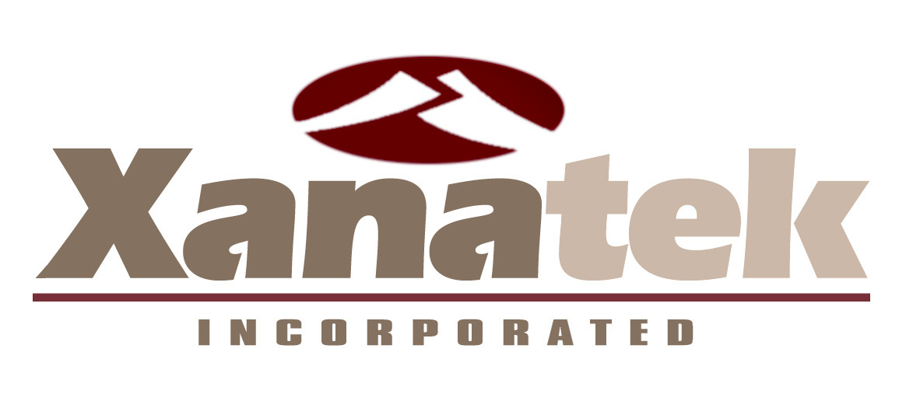

July 30, 2026

AGENCY INFO

AGENT Number

CONTACT:

We need your help! Our agency is utilizing the Image Management System for Insurance (IMS I) by Xanatek for agency management. We would like to download our client information using the AL3 format. Xanatek is can support AL3 data from Ivans, Connective or direct through the internet.

Please provide us with the following information:

Method of Download

Select One: IVANS Connective Technologies(TEAMUP) Direct Internet Batch
Other:_________________________________________

If IVANS - Please provide our Y-Account:_________ and password:_____________

If Connective Technologies – Logon name: ________ and password: ____________

Please contact Steve Trovatore (800) 820-1665 or Steve@Xanatek.com at Xanatek to begin the process or if you have any questions.

Please contact me here at the agency if you have any questions.

Sincerely,

YOUR NAME

